Chapter 7B: Cloud Connectivity using HTTP 1.1

Time 2 Hours

At this end of Chapter 7B you will understand:

* The HTTP 1.1 protocol
* The architecture and use model of the WICED http_client library
* How to use CURL to test HTTP(S) servers
* How to use HTTP(S) to read & write data to the Cloud using RESTful APIs
* How to create an HTTPS connection in WICED using TLS
* How to test your HTTP client using HTTPBIN

7B.1 Introduction 3

7B.2 HTTP 1.1 Protocol 3

7B.2.1 Client Request Message Format 4

7B.2.2 Client Request 🡪 Start Line 4

7B.2.3 Client Request 🡪 Start Line 🡪 HTTP Methods 4

7B.2.4 Client Request 🡪 Start Line 🡪 Resources 5

7B.2.5 Client Request 🡪 Start Line 🡪 Options 6

7B.2.6 Client Request 🡪 Headers 6

7B.2.7 Client Request 🡪 Content Body 7

7B.2.8 Server Response Message Format 7

7B.2.9 Server Response 🡪 Start Line 8

7B.2.10 Server Response 🡪 Start Line 🡪 Status Codes 8

7B.2.11 Server Response 🡪 Start Line 🡪 Status Message 8

7B.2.12 Server Response 🡪 Headers 9

7B.2.13 Server Response 🡪 Content Body 9

7B.3 Client for URLs or "C" URL (CURL) 9

7B.4 Representational State Transfer (REST) & RESTful APIs 14

7B.4.1 Web APIs 15

7B.5 WICED HTTP 1.1 Client Library 16

7B.6 Httpbin.org 18

7B.7 Initial State (Advanced) 19

7B.7.1 Introduction 19

7B.7.2 Using Initial State 21

7B.8 Exercise(s) 27

Exercise - 7B.1 Use CURL to access http://httpbin.org 27

Exercise - 7B.2 Use CURL to access https://httpbin.org using TLS 27

Exercise - 7B.3 Use the WICED kit to Get Data from httpbin.org 28

Exercise - 7B.4 Use the WICED kit to Get Data from httpbin.org using TLS 29

Exercise - 7B.5 Use the WICED kit to Post Data to httpbin.org 29

Exercise - 7B.6 Use the WICED kit to Post Data to httpbin.org using TLS 30

Exercise - 7B.7 Use a Web API for Temperature Conversion 30

Exercise - 7B.8 (Advanced) Initial State – Virtual LED Controlled using APIARY and CURL 31

Exercise - 7B.9 (Advanced) Initial State – LED State Controlled by Hardware 31

Exercise - 7B.10 (Advanced) Initial State – Temperature & Humidity 32

Exercise - 7B.11 (Advanced) Initial State – Graphing Temperature & Humidity 32

Exercise - 7B.12 (Advanced) Send Request Using Text Strings 32

7B.9 Related Example "Apps" 33

7B.10 Known Errata + Enhancements + Comments 33

# Introduction

When HTTP came on the scene in the early 90's, it was principally used to send static HTML pages. Over time, dynamic HTTP came into common use (reading and writing databases and creating HTML on the fly). Many companies built big teams of people to develop and deploy HTTP based applications internally to their employees and externally to their customers.

As IoT emerged, it was only natural and financially advantageous for companies to extend their existing infrastructure to enable IoT devices to communicate with the existing Web services. Although HTTP has issues which make it less than "perfect" for IoT, it is still the most important standard because of the huge investment that has been made in the existing Internet infrastructure.

There are essentially two versions of HTTP, 1.1 and 2.0. Although conceptually similar, they are materially different in their implementation and as such are treated as two separate chapters in this class.

HTTP 1.1 was released in 1999 and as of 2017 it still serves the bulk (>50%) of the web traffic. HTTP 2.0, which was released in 2015, brings many performance benefits but has seen slow uptake in the market (as of 2017 only ~30% of web browsers support it).

WICED supports both protocols, but with two separate libraries.

# HTTP 1.1 Protocol

HTTP 1.1 is an application layer, single transaction, stateless, plain-text, client-server protocol. This means that a client (e.g. your WICED device) opens a connection to a TCP Server (in the Cloud), sends an ASCII text request, then the Server responds, and the connection is closed. There is no memory in the protocol itself but there might be in an application e.g. Cookie.



HTTP Requests and responses are made up of one mandatory start line, an optional group of HTTP headers (same format for Client and Server) and one optional Content body (same format for Client and Server).

## Client Request Message Format

An HTTP transaction starts with the client opening a TCP socket to the server (or a TLS TCP socket to the server). The client then sends up to four things:

* **Client Request Start Line (7B.2.2 )**
* **Headers (7B.2.6 )** (one or more strings of the form of "headername:headervalue\r\n")
* A "\r\n" line after the last header
* Optional: **Content Body (7B.2.7 )** (one payload with as many bytes as required e.g. a file or an html page or a JSON document)

## Client Request 🡪 Start Line

The Client Request Start Line has five elements:

* The **HTTP Method (7B.2.3 )**
* The requested **Resource (7B.2.4 )** path
* Optional**: Options (7B.2.5 )** (a '?' followed by a list of optional arguments separated by '&')
* The version of HTTP (for this chapter it will always be "HTTP/1.1"
* A "\r\n"

An example legal client request start line is:

GET /ask HTTP/1.1

In the above example, *GET* is the HTTP Method, */ask* is the Resource, and *HTTP/1.1* is the version.

## Client Request 🡪 Start Line 🡪 HTTP Methods

There are 9 [HTTP methods](https://developer.mozilla.org/en-US/docs/Web/HTTP/Messages) which are sometimes called "verbs" because they request a simple action from the Server to act upon a Resource. The verbs fit into two categories (Safe/Unsafe, Idempotent/non-Idempotent)

Safe – the method doesn't change anything on the Server and can be run without fear of side effects. Any method that changes anything on the server is therefore Unsafe.

Idempotent – no matter how many times you run the method, the state on the server state remains the same. For example, if you "PUT" a document to the server, it will only have one instance on the server no matter how many times you run it. As another example, a DELETE will have the same effect no matter how many times you run it. A non-idempotent method changes the state of the server every time you run it. For example, a POST might insert data in the database every time it is run.

[GET](https://developer.mozilla.org/en-US/docs/Web/HTTP/Methods/GET) (safe, idempotent) – The Server will reply with an HTTP response with the Content Body of the requested Resource (i.e. the file). The Server response will include Headers that will tell the Client how long the Content Body is "Content-length" and what is the MIME-Type (7B.2.7 ) of the Content Body "Content-type".

[HEAD](https://developer.mozilla.org/en-US/docs/Web/HTTP/Methods/HEAD) (safe, idempotent) – This Method performs the same operation as "GET" except it only replies with the Headers and does not return the Content Body.

[PUT](https://developer.mozilla.org/en-US/docs/Web/HTTP/Methods/PUT) (unsafe, idempotent) – The Client asks the Server to replace the Resource with the Content attached to the message. The Server knows the length of the Content based on the Header "Content-length" and the MIME Type based on the Header "Content-type".

[PATCH](https://developer.mozilla.org/en-US/docs/Web/HTTP/Methods/PATCH) (unsafe, idempotent) – With this method the Client is requesting a partial PUT e.g. if the Resource is a document that contains a name and an age, then the Client could PATCH just a new age by having content with the updated age by sending a JSON document with "{age:49}".

[POST](https://developer.mozilla.org/en-US/docs/Web/HTTP/Methods/POST) (unsafe, non-idempotent) – The Client asks the Server to update the Resource based on the Content attached to the message. An example of this method is sending a temperature to the server which will be saved into the database. The Server knows the length of the Content based on the Header "Content-length" and the MIME Type based on the Header "Content-type".

[DELETE](https://developer.mozilla.org/en-US/docs/Web/HTTP/Methods/DELETE) (unsafe, idempotent) – This Methods asks the Server to remove the Resource.

[OPTIONS](https://developer.mozilla.org/en-US/docs/Web/HTTP/Methods/OPTIONS) (safe, idempotent) – This Method asks the Server to respond with an HTTP message that has a "Options" header that enumerates the list of legal HTTP Methods for that server.

TRACE (safe, idempotent) – This Method is an infrequently implemented debugging Method that should cause the server to reply with the Client Message (echo'd back).

[CONNECT](https://developer.mozilla.org/en-US/docs/Web/HTTP/Methods/CONNECT) – This method requests the Server to open a tunneling TCP connection. This method is probably never used in an IoT application.

You should be aware that the idempotence and safety of these methods is established by convention. There is no technical reason why a "GET" couldn't delete the resource or a "PUT" couldn't return the resource, but people who implement web servers like that should be beaten for the dogs that they are.

## Client Request 🡪 Start Line 🡪 Resources

When you look at an http web address (sometime known as a Universal Record locator (URL)) you typically see:

* http://server.com/path

or

* http://server.com/path?option=28

These URLs are of the form of:

* "http:" specifies the protocol.
* "server.com" is the DNS name of the HTTP server
* "/path" the location of the resource on the HTTP server.
* "?option=28" is an option that is sent to the server (see next section)

In generic terms, a URL is "protocol://serverName/path?option".

In HTTP 1.1 the 2nd and 3rd elements of the Client Request line are the Resource & Options which are the same as the path and options from a URL. For example, you might see an HTTP request that looks like this:

GET /resource HTTP/1.1

Which is a request to the server to please send the document located at "/resource" as an HTTP response.

## Client Request 🡪 Start Line 🡪 Options

Options are appended to the resource location by placing a "?" at the end of the resource path. You can then specify options by adding "option=value" or just "option". You can specify multiple options by separating them with "&". These options are sometimes used to send commands or other information to the server e.g. "user=arh&password=secret".

An example request with an option to format the response as "simple" (what "simple" means is part of the application semantics) might look like this:

GET /resource?format=simple HTTP/1.1

## Client Request 🡪 Headers

The [HTTP Headers](https://developer.mozilla.org/en-US/docs/Web/HTTP/Headers) are just a list of "name: value" pairs, one per line with the name and the value separated by a ": ". The names are case insensitive. The Headers are used to send metadata between the client and server. The metadata may include the type of file being sent, how many bytes are in the file, what kinds of content can the client or server accept, what is the client user, what is the client password … and on and on and on. The Host header is required in all client requests. Other headers may be required depending on the request. Here are a few example Header lines:

Host: example.com

Content-type: application/json

Content-length: 129

Accept: application/json

X-Some-Header: 1239asdf

Set-cookie: nsatrack=129

**You must send "\r\n" at the end of each header line, but WICED inserts this automatically for you if you use the WICED HTTP library API functions.**

The IANA has a [standard list](https://www.iana.org/assignments/message-headers/message-headers.xhtml) of headers and has developed a registration scheme for people to add more. In addition, you can define your own headers that can mean anything that your server/client can agree on. The names of these Headers are generally in the form of "X-something".

Every request to a server must include the "Host" header. Also, there are two headers for specifying the type and length of the content payload, "Content-type" and "Content-length" which are required for any request that includes a payload.

## Client Request 🡪 Content Body

The optional body of the message can be sent by the client. It is just a string of bytes that starts right after the "\r\n" after the headers. The number of bytes sent is specified by the header "Content-length" and the format of the body is specified by the header "Content-type".

The legal values of the "Content-Type" header is also known as a "MIME Type". MIME (an old acronym that means Multipurpose Internet Mail Extension) types are specified by the [IANA](https://www.iana.org/) and can be found on their [website](https://www.iana.org/assignments/media-types/media-types.xhtml). Some of the types that are probably useful for IoT applications include:

* application/json
* application/xml
* text/plain

The list runs to 100's of possible types



## Server Response Message Format

Upon receiving a request from a Client, the Server will respond with:

* **Server Response Start Line**
* Optional **Headers** (same format as the client header)
* Optional **Content** **Body** (same format as the client Content body)

The client can then:

* Close the connection

or

* Leave the connection open to possibly send another request (the Server will eventually close the connection after a timeout of unspecified length … generally in the range of seconds.

## Server Response 🡪 Start Line

The HTTP Server response start line will have 4 elements:

* The protocol (probably "HTTP/1.1")
* The [Status Code](https://www.iana.org/assignments/http-status-codes/http-status-codes.xhtml) (a number as defined by the IETF)
* The Status Message (a short human readable text version of the status code). This should not be processed by your client to act, use the Status Code instead.
* A line with just "\r\n"

An example server response start line (indicating success) is:

HTTP/1.1 200 OK

Or a failure with the infamous 404 error:

HTTP/1.1 404 NOT FOUND

## Server Response 🡪 Start Line 🡪 Status Codes

The server will respond with a 3-digit status code that is defined by the IETF in [section 10 of RFC2616](https://tools.ietf.org/html/rfc2616#section-10). The codes include a wide range of possible things that happened on the server including:

* 200 OK
* 201 Created
* 202 Accepted
* 400 Bad Request
* 404 Not Found

There is a practical discussion of these codes on the Mozilla foundation [website](https://developer.mozilla.org/en-US/docs/Web/HTTP/Status).

## Server Response 🡪 Start Line 🡪 Status Message

In addition to the Server Status Code, the server will respond with a short description of the status code e.g. "OK" or "Created". You should treat the textual response as informational only. You should not parse it and make decisions based on it. For your application logic only use the Server Status Code.

## Server Response 🡪 Headers

The server uses exactly the same Header format scheme as the client.

## Server Response 🡪 Content Body

The server uses exactly the same Content Body format scheme as the client.

# Client for URLs or "C" URL (CURL)

CURL is a utility for sending and receiving HTTP requests which built into Unix (Linux, MacOS) and is also available for Windows (but not built in). CURL is a handy tool to help you figure out what an HTTP website is doing so that you can build your WICED program to do the same thing. CURL will let you create HTTP requests with all the commands (GET, POST, PUT, …), any headers you want, plus any content that you want. As with most Unix utilities it is completely out of control with regards to the number of options.

For example, if you want to see what options are available on the "anything" resource on the httpbin.org website you can type the command:

curl -v -X OPTIONS http://httpbin.org/anything

This example will build an HTTP message that looks like this:

OPTIONS /anything HTTP/1.1

Host: httpbin.org

The website will then reply with the HTTP options that it supports and you will see the output on the terminal (because of the -v).

The data sent from your client to the server is shown as lines starting with ">" while the response data from the server is shown as lines starting with "<".

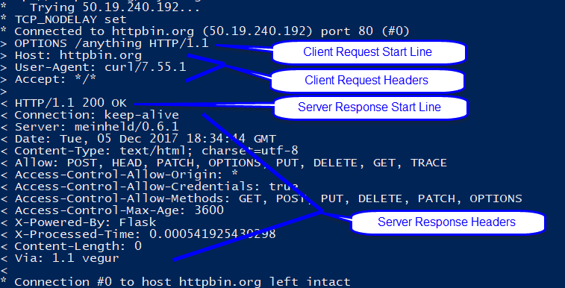

CURL supports both http and https. If you specify the root certificate using the --cacert option, CURL will validate the certificate before proceeding with the http transaction. If the server requires the client certificate (e.g. AWS), using the --cert option to provide the client's certificate file.

Note that if you specify JSON with the -d option and your JSON has quotes in it, they must be escaped using backslash (\) characters. For example:

curl -v -X POST -H "Content-type: application/json" -d "{\"Key1\":\"Value1\"}" http://httpbin.org/anything

If you are using Windows PowerShell to execute the CURL command, replace the double quotes that are not inside the JSON message with single quotes. In that case the above command would be:

curl -v -X POST -H 'Content-type: application/json' -d '{\"Key1\":\"Value1\"}' http://httpbin.org/anything

When you specify a body (such as with -d), CURL will automatically calculate and send the Content‑length header for you.

In the table below, I show a bunch of CURL commands that are sending requests to httpbin.org which I will talk about in detail in a later section. Some of the useful CURL options are:

| **Option** | **Explanation & Example** |
| --- | --- |
| -v | Verbose: all the http request and response will be echo'd to the screen |
| curl -v http://httpbin.org/get |
| -X "command" | CURL will execute the specified HTTP command GET, POST, PUT, DELETE, OPTIONS, TRACE, CONNECT, HEAD. If you use PUT, POST you need to specify the content by adding --data |
| curl –v –X 'OPTIONS' http://httpbin.org/get |
| -H "headername:headervalue" | Adds a header to the HTTP request. You can have multiple –H to add multiple headers. If you specify a header that CURL does automatically e.g. "Content-Type:" it will be overridden by specifying this option. |
| curl -v -H 'x-some-custom: someValue' http://httpbin.org |
| -d "data"  --databinary "data" | Specifies the data for a PUT, POST. CURL will automatically add the "Content-length:" header. |
| curl -v -X 'PUT' -H 'content-type: application/json' -d '{asdf}' http://httpbin.org/put |
| -o filename | Send output to filename. This only sends the content, not the headers to the file |
| curl –o blah.json http://httpbin.org/get |
| --head | CURL will make the method HEAD. You will need to use the –v to see the headers because there will be no content sent back by the http server |
| curl –v --head http://httpbin.org/get |
| --cookie "value" | This will add the header "Cookie: value" to your header |
| curl –v --cookie 'name=arh' <http://httpbin.org/get> |
| --cacert server_cert.pem | Verify the certificate of the https connection with the certificate.pem root ca. In the example below, if the httpbin.pem does not match the root certificate received from httpbin.org the connection will fail. |
| curl --cacert httpbin.pem https://httpbin.org/get |
| --cert client_cert.pem | Send client_cert.pem to the HTTPS server to verify the client identity |
| curl --cert client_cert.pem https://httpbin.org/ |

This [link](https://curl.haxx.se/docs/httpscripting.html#The_HTTP_Protocol) (https://curl.haxx.se/docs/httpscripting.html#The_HTTP_Protocol) takes you to a useful tutorial using CURL with HTTP.

# Representational State Transfer ([REST](https://en.wikipedia.org/wiki/Representational_state_transfer)) & RESTful APIs

REST is a design philosophy developed by Thomas Fielding for his [PhD Dissertation](http://www.ics.uci.edu/~fielding/pubs/dissertation/top.htm). This philosophy has achieved wide acceptance on the Internet, and many people at least pay lip service to supporting it. In Dr. Fielding's thesis he described 7 characteristics: Uniform Interface, Stateless, Cacheable, Client-Server, Layered System, Code-on-demand. If you want to understand more of the philosophy please go read his thesis or google "rest api definition" or "rest api tutorial" and you will find more lunacy, militancy and religion than you probably care to read about.

So now what? A RESTful API is a webserver that implements REST. In other words, an HTTP Client can interact with a RESTful HTTP Server using the principals outlined by REST. Practically and most commonly this means:

* You send and receive JSON documents
* The returned HTTP Server Status code tells you what happened with your request
* The HTTP resources are nouns such as:
  + /companies return a list of the companies
  + /companies/cy is a list of the information about Cypress
  + /companies/cy/products a list of all of Cypress products
* The HTTP Client Methods are verbs such as:
  + GET /companies/cy/products will return a JSON document with a list of all the products
  + POST /companies will add a new company to the server (from the attached JSON document)
  + DELETE /company/ftdi will delete FTDI from the list of companies.

It is common to use options on the resource to perform actions such as:

* Filtering /companies/cy/products?type=wifi
* Pagination /companies?page=27
* Searching /companies?search=Cypress
* Sorting /companies?sort=rank_asc

## Web APIs

A Web API is a publicly available RESTful API. On the Internet, there is a wild-wild-west of APIs. Companies and people open their APIs for all the normal reasons including profit, fame, ego, altruism etc. There are a bunch of useful ones out there which you can reliably use in your projects. To find APIs, some web directories have been created including:

* <https://www.programmableweb.com/category/all/apis>
* https://github.com/APIs-guru/openapi-directory

A few APIs that might be useful include:

* Weather - <https://www.wunderground.com/weather/api>
* Twitter - https://dev.twitter.com/overview/api
* Google Translate - <https://cloud.google.com/translate/docs/translating-text>

A vast number of the APIs on the internet use an "API key". This is generally a string of 20ish characters that enable you to access the API. When you register on the website of the API provider they will tell you the API key. There are two common methods for sending the API keys

* HTTP option /blah/foo/bar?apikey=1234abcd
* HTTP header "X-myapikey: 1234abcd"

# WICED HTTP 1.1 Client Library

In the previous sections of this chapter I talk about the HTTP Protocol and the way it works and is used. In this section I start the process of explaining how to use WICED to implement HTTP. Fundamentally WICED provides you APIs to build the Client Request Line, Headers and Content, then parse the output that comes back in the form of a server response.

The WICED SDK has several built-in HTTP libraries including protocols/HTTP_client which provides support for HTTP 1.1 Clients. You can find the documentation for this library under "Components🡪 IP Communication 🡪 HTTP 🡪 HTTP Client". This library supports both HTTP and HTTPS.

To make the HTTP_client library work you:

* Initialize the http client http_client_init
* Optionally initialize the client identity wiced_tls_identity
* Optionally configure the TLS properties http_client_configuration_info_t
* Optionally initialize the HTTP Server root cert wiced_tls_init_root_ca_certificates
* Make a connection to the HTTP server http_client_connect
* Initialize the HTTP request http_request_init
* Initialize an array of HTTP headers http_header_field_t[]
* Write the headers http_request_write_header
* Write the end (the blank line "\r\n") http_request_write_end_header
* Optionally write the content body http_request_write
* Flush the writes http_request_flush

Then you wait for the callback. In the callback function (which you registered when you created the client) you will get the arguments, http_client_t *, http_event_t and http_response_t.

**http_client_t**: The same callback function can be used to process requests from multiple http_client_t structures, so when the callback runs, the callback will tell you which http_client_t is calling you back.

**http_event_t**: The http_event_t is an enumerated datatype of the following events:

* HTTP_CONNECTED Notification of successful connection including TLS
* HTTP_DISCONNECTED Perform error recovery or cleanup
* HTTP_NOEVENT Nothing
* HTTP_DATA_RECEIVED Process the http_response_t

**http_response_t:** For every http_request_t, WICED automatically creates an http_response_t. The response is a structure:



The WICED SDK provides you with a function called http_parse_header which will search through the HTTP header, which is an array of bytes, and will find all the headers that you tell it to look for and parse their values.

The structure has a pointer to the payload and the number of bytes. You are responsible for parsing (or whatever) that data. Don't forget the WICED cJSON library may help you.

All this data is freed when you call wiced_request_deinit. Typically, you will call wiced_request_deinit from the HTTP callback for the event HTTP_DATA_RECEIVED when the value of remaining_length in the response structure is equal to zero.

There is also a function http_client_deinit that you should call after the server disconnects. This function must NOT be done inside the HTTP callback, because you would be removing a thread that is currently running. Therefore, in the HTTP callback, when you get the HTTP_DISCONNECTED event you should set a flag and then call wiced_client_deinit from a different thread (like application_start) when the flag is set.

# Httpbin.org

Httpbin.org is a website that was put up to help people test their HTTP (and HTTPS) requests. You can send PUT, POST, GET etc. and it will respond with something simple, often in JSON format to "echo" what you sent.

You can build HTTP requests in CURL to test your ideas about how to interact with different HTTP endpoints (i.e. resources). You could, for example, go to <http://httpbin.org/get> in your browser and it will return:



There are a bunch of endpoints (resources) which allow different HTTP methods to be tested. We will mostly use the /anything resource since (as the name implies) it allows just about anything. It will respond back with an echo of the data that you sent so you can compare to what you intended to send.



# Initial State (Advanced)

## Introduction

[Initial State](http://www.initialstate.com/) is a Web API based IoT analysis platform. In other words, they are setup to let you stream data from your IoT devices into their cloud (i.e. they are a cloud services provider). Once your data is on their cloud, you can log into their web platform and display and analyze your data with their extensive library of graphical web based tools.

Data that you send to the Initial State cloud is organized into a Stream of time stamped key/value pairs. All Streams of data are grouped together into Buckets (which can hold one or more Streams). Each key/value data point that you send can have a time attached with it, or Initial State can automatically attach the timestamp of your upload to the data point.

The key in the key/value pair should be a textual description of what you are recording e.g. temperature, humidity, LED State, etc. The value can be a real number, a text string, an [emoji](https://emoji.codes/) of the form ":code:" e.g. ":smile:".

Data can be displayed using one or more "Tiles". Each tile can display a summary (such as "on" or "OFF"), a line graph of the values over time, a bar graph, etc. The figure below shows four value tiles and four line graph tiles. You can move Tiles around on the screen or resize them by right clicking on a Tile and selecting "Unlock Layout". You can zoom in on the time scale by clicking in the time bar along the top edge of the Tile screen and dragging the circles to the time range that you want to see.



There is also a Waves App, Line Graph App, and File Source Viewer that can be used to show data in different ways.

For example, if you lived in Kentucky near the Elkhorn Creek you could create a Bucket called "Elkhorn Creek" that has two Streams of data: one with the depth of the water in the creek and another with the temperature in the barn. You could then use the Line Graph App to display the water depth as shown in the figure below.



## Using Initial State

### Setting up an Account, a Bucket, and a Tile

* Create a free account at [www.initialstate.com](http://www.initialstate.com).
* Create a new bucket by pressing the little "+" in the top left part of the screen next to the cloud icon.

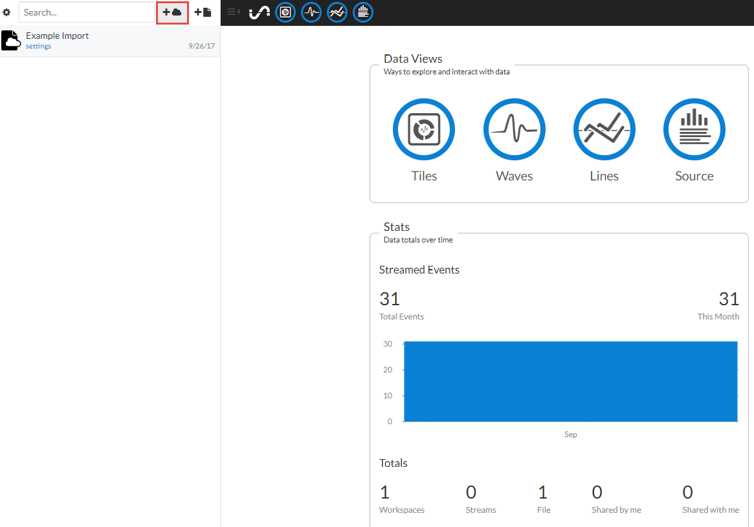

Enter a name for the bucket, check the *Configure Endpoint Keys* box to let the server create a Bucket Key and an Access Key, and click the *Create* button at the bottom of the window



Note: you can get back to this window later by clicking on "settings" under the bucket name.

Once you have the Bucket setup, you should see the App Launcher as shown below. Click on the bucket name from the "shelf" window on the left (1) to make sure you are looking at the correct bucket and then click the App Launcher button (2). Use the three lines with an arrow to open/close the shelf (3). You can also use the buttons along the top to switch to the Tile App, Waves App, Line Graph App, and File Source views (4).

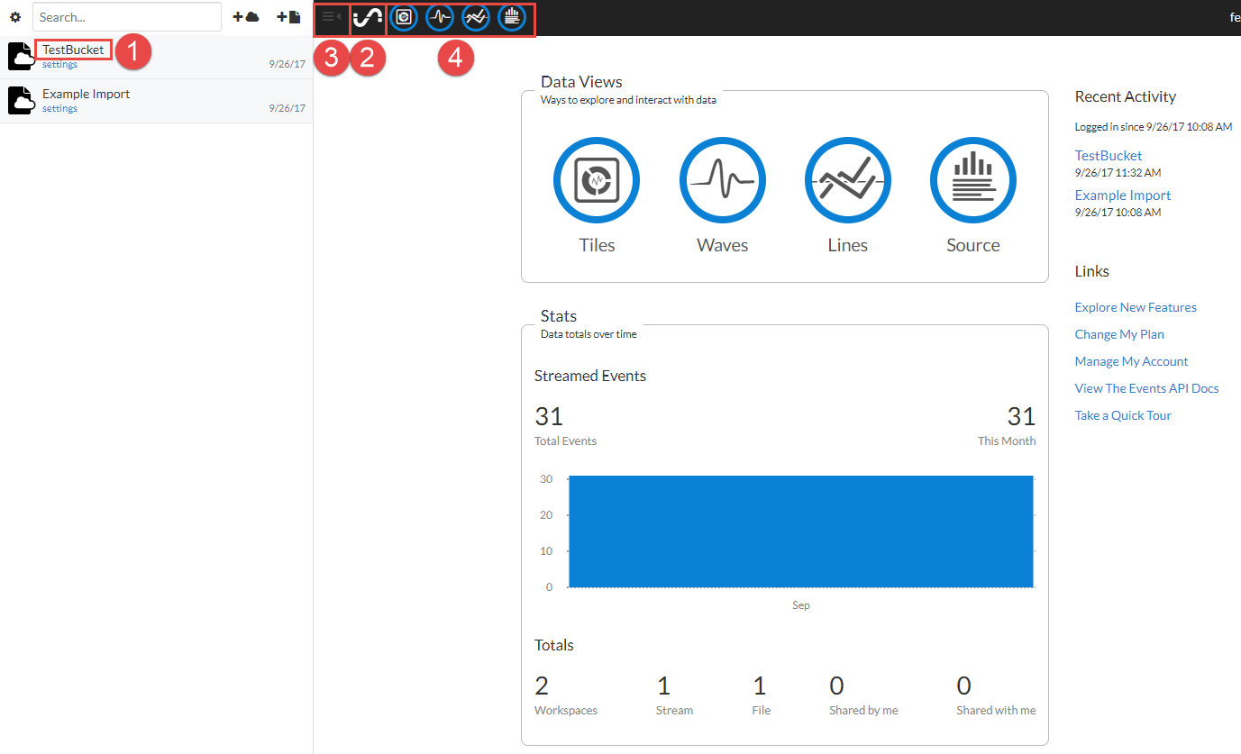

To add a new tile, first select the Tiles App, click Edit Tiles (1), and then Add Tile (2). Enter the information that you want to display (3) and the tile will be created. Click outside the Add Tile window to close it. You will now see your tile, but it will be empty until you POST data to the bucket for the key that you created.

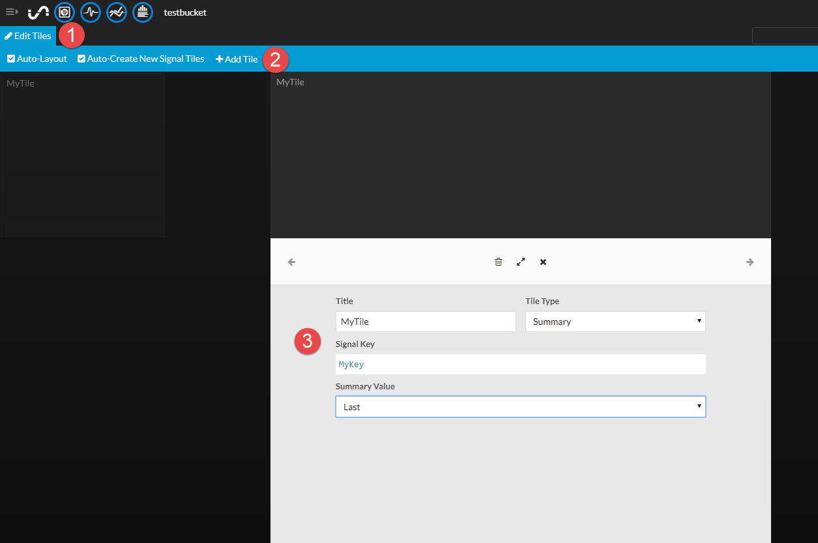

### Sending HTTP Data

You can send HTTP POST requests to Initial State using one of two methods:

JSON

* Server = groker.intialstate.com
* Resource = /api/events
* HTTP Header for X-IS-AccessKey: <yourAccessKey>
* HTTP Header for X-IS-BucketKey: <yourBucketKey>
* HTTP Header for Content-Type: application/json"
* HHTP Header for Content-Length: <yourJsonLength>
* A JSON Document with an Array of Keymaps and values. For example, to set the key named "switch" to a value of "on", the JSON would be:

{"key":"switch","value":"on"}

HTTP Options

* accessKey
* bucketKey
* eventKey0
* eventValue0

For example, you could send an event to set the key called "switch" to a value of "on" by sending an HTTP POST request with the following settings:

* Server = https://groker.initialstate.com
* Resource = /api/events
* Options = accessKey=<yourAccessKey>&bucketKey=<yourBucketKey>&eventKey0=switch&eventValue0=on

### Using APIARY

Initial State has documented their Web API with a tool called "[APIARY](http://docs.initialstateeventsapi.apiary.io/)". This is a web based tool which shows all the APIs and how to use them with examples. It can also switch to "console" mode where you can fill in the boxes in HTTP requests and it will send them to the Initial State Web Server.

You can access the APIARY documentation from InitialState by clicking on the link "View The Events API Docs" from the right side of the App Launcher (remember, click the sine wave to get to the App Launcher). You can also access it by clicking "support" at the top right corner of the window, selecting "Streaming -> Using the Events API", and then clicking on "documented and testable on apiary". The initial APIARY window looks like this:



From the left panel, click on "Event Data -> Events JSON" and then click the banner "Send Events" from the center panel. Next, click the button that says "Switch to Console" on the right panel. Once you do that, you will see the following window that includes documentation on sending events (center panel) and a test console that you can use to send POST requests (right panel).

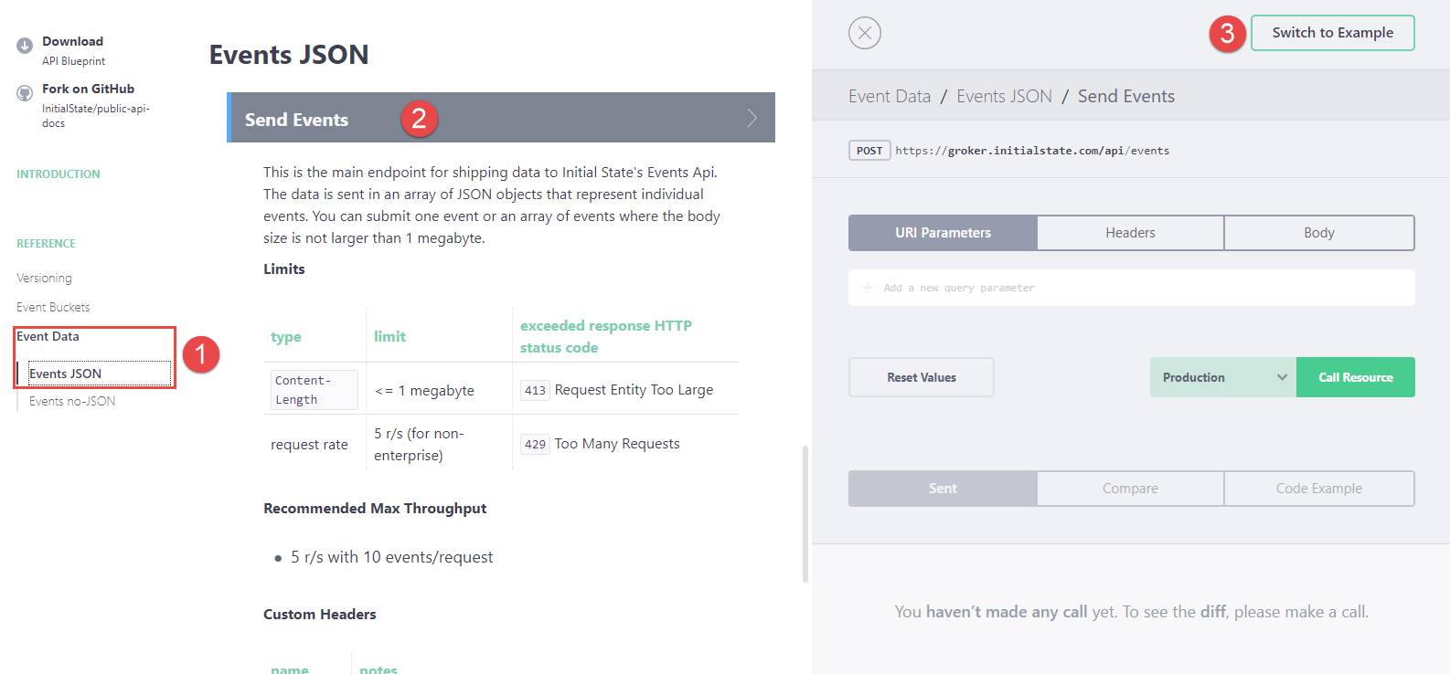

From the console, you can create and send HTTP requests. For example, to send the value "on" to a key called "switch" from the console, you would do the following:

First click on "Header" and fill in your API Key and Bucket Key. The header for Content-Type is already filled in for you and the Content-Length will be automatically calculated.



Then click on "Body" and type in the JSON document for the message.



When you press "Call Resource" it will show you the HTTP 1.1 document and the result.



If you have a Tile set up to monitor the state of the key "switch" you will see its value change to "on" once the message is received.

# Exercise(s)

* 1. Use CURL to access <http://httpbin.org>

The Website httpbin.org is a public server HTTP debugging utility. It will let you make requests and then tell you what is happening by echoing back what you sent in JSON format.

Look at the website then:

1. Run the command: *CURL -v -X GET* [*http://httpbin.org/anything*](http://httpbin.org/anything)
   * Hint: If your WiFi AP has a proxy server, CURL will not be able to connect (unless you specify the proxy server). You can connect to the WW101WPA AP, which doesn't require a proxy.
   * Hint: If you are using Windows, CURL is provided in the class material. To use it:
     + Go to Software_Tools/curl-<version>-win32-mingw/bin
     + Shift-Right-Click in the window and select either "Open command window here" or "Open PowerShell window here"
     + From the new window, run the command as *.\curl <other arguments>*.
       - The leading dot and slash are required in Windows because in some cases Windows aliases "curl" to a different function that is similar to CURL but is not the same.
     + If you are using PowerShell, remember to use single quotes instead of double quotes (except inside a JSON string).
2. Use CURL to do a POST to the resource /anything
3. Use CURL to do a GET from the resource /html.
   1. Use CURL to access <https://httpbin.org> using TLS

Use a TLS connection to access httpbin.org. The steps are:

1. Use a web browser to save the certificate for <https://httpbin.org>.
   * You must save the root certificate to use in CURL. It will not work with the intermediate certificate.
   * Put the certificate in the same folder as the CURL executable to simply specifying the path.
2. Use CURL to do a GET from <https://httpbin.org/anything>
   * You will need to use the --cacert option in CURL to provide the certificate file.
3. Look at the log file to see the TLS handshaking occurring.
   1. Use the WICED kit to Get Data from httpbin.org

Copy/Run a project to get data from httpbin.org using the WICED WiFi kit. The project will perform a GET from the /html resource and then from the /anything resource. The steps are:

* Copy the project from ww101key/07b/03_httpbin_get to your project location.
* Change the app name in the make file to match your path.
* Update the WiFi configuration parameters if necessary.
* Open a serial terminal connection to the WICED kit.
* Create a make target, build, download, and run the project.
* Observe the results in the terminal window.
* Answer the following questions by examining the firmware:

1. Which server port is used for HTTP (non-secure)?
2. What function is called each time an HTTP event occurs? Where is that specified?
3. What header(s) is/are sent with each request?
4. What is the purpose of the semaphore "httpWait".
5. How many response payloads do we get from the request to /html?
6. Where is the http_request_deinit called? Why?
7. What is the variable "connected" used for? Why is it needed?
8. Uncomment the section of code to wait for the server to disconnect between requests. How long does the server wait before closing the connection?
   1. Use the WICED kit to Get Data from httpbin.org using TLS

Copy/Run a project to GET data from httpbin.org using the WICED WiFi kit using a TLS connection. The steps are:

* Copy the project from ww101key/07b/04_httpbin_get_tls to your project location.
* Change the app name in the make file to match your path.
* Update the WiFi configuration parameters if necessary.
* Examine the makefile to determine where the certificate will be read from. Copy the certificate that you used for the CURL TLS exercise to the correct location/name.
  1. Hint – run a "clean" in WICED Studio after copying the file.
* Open a serial terminal connection to the WICED kit.
* Create a make target, build, download, and run the project.
* Observe the results.
* Answer the following questions by examining the firmware:

1. Which server port is used for HTTPS (secure)?
2. What function call and parameter specifies that the connection should use TLS?
3. Where is the certificate stored inside the device?
4. How is the certificate read into the firmware?
   1. Use the WICED kit to Post Data to httpbin.org

Copy/Run a project to POST data to httpbin.org using the WICED WiFi kit. The resource is /anything. The steps are:

* Copy the project from ww101key/07b/05_httpbin_post to your project location.
* Change the app name in the make file to match your path.
* Update the WiFi configuration parameters if necessary.
* Open a serial terminal connection to the WICED kit.
* Create a make target, build, download, and run the project.
* Observe the results.
* Answer the following questions by examining the firmware:

1. What headers sent with the POST request?
2. What is the JSON content that is posted?
   1. Use the WICED kit to Post Data to httpbin.org using TLS

Copy/Run a project to POST data to httpbin.org using the WICED WiFi kit using a TLS connection. The steps are:

* Copy the project from ww101key/07b/06_httpbin_post_tls to your project location.
* Change the app name in the make file to match your path.
* Update the WiFi configuration parameters if necessary.
* Examine the makefile to determine where the certificate will be read from. Note that this project uses a different method to store the certificate in the device than the GET TLS project, but the file location on the PC is the same.
* Open a serial terminal connection to the WICED kit.
* Create a make target, build, download, and run the project.
* Observe the results.
* Answer the following questions by examining the firmware:

1. Where is the certificate stored inside the device?
2. How is the certificate read into the firmware?
   1. Use a Web API for Temperature Conversion

Create a WICED project that will read the temperature from the AFE shield, call the Web API to convert it from C to F, then display it on the LCD screen. We have setup an account with Neutrino API which will provide the conversion. The site and resource path for the conversion are:

<https://neutrinoapi.com/convert>

The options required are:

from-value=<the value to convert>

from-type=C

to-type=F

user-id=wicedwifi101

api-key=kyM2OWa22SZ1B5PGE7DvjSi67sPMXHTNXXENVut8JvmjkjMo

* Hint: Go to <https://neutrinoapi.com/api/convert> to see the documentation. Click on "Test API -> API Tools -> Convert" to try it out on the web.
* Hint: Use CURL to test the message and see the response that you will get back.
* Hint: You will need to get the certificate for neutrinoapi.com or one of its CAs from a web browser and include it in the firmware (use one of the three methods discussed in the TCP/IP Sockets chapter.
* Hint: When the response is received, you will need to parse the JSON from the body to get the converted temperature value. Refer to the JSON parser examples from the library chapter.
  + The value is returned as string, not a number.
* Hint: Refer to the Sensor Data project in the Library chapter for an example of reading the values from the shield and displaying them on the screen.
* Hint: Refer to the httpbin.org GET project that uses TLS.
  1. (Advanced) Initial State – Virtual LED Controlled using APIARY and CURL
* Go to [www.initialstate.com](http://www.initialstate.com) and signup for an individual trial account.
* Create a new Bucket called "TestBucket". See the section earlier on Initial State for detailed instructions.
* Use the APIARY interface to write ON and OFF to the LED and see that the state changes in the Tile.
  + Hint: You will need to enter the AccessKey and BucketKey for you bucket either as headers or as URI Parameters. Placeholder headers are provided with default values. You can find the values for your bucket by going to the bucket settings on the shelf.
  + Hint: The body should be a JSON document that sends "key":"LED_State" with "value":"ON" or "value":"OFF".
  + Hint: The first time you write to a key from APIARY, it will create a summary tile for you automatically so you won't need to create it manually.
* What status code is returned when you send the message? Look up the code to see what it means.
* Use CURL to send HTTP POST messages to turn ON and OFF the virtual LED. Verify that it changes in the Tile.
  1. (Advanced) Initial State – LED State Controlled by Hardware

Create a WICED project to turn on and off the virtual LED on Initial State when the button on your AFE Shield is pressed.

* Hint: Start with the project that sends data to httpbin.org.
* Hint: You will need to get the certificate for initialstate.com or one of its CAs from a web browser and include it in the firmware (use one of the three methods discussed in the TCP/IP Sockets chapter.
* Hint: The HTTP Bin project has the server name in 2 places. Search for it and replace the 2nd one with SERVER_HOST.
* Hint: Don't forget to escape the quotes inside the JSON message with backslashes (\").
* Hint: Since the server can disconnect at any time, you should open the connection each time the button is pressed, send the request, and then close the connection. You can set a flag (or a semaphore) inside the callback function when *response->remaining_length* equals 0 to let you know when to close the connection.
  1. (Advanced) Initial State – Temperature & Humidity

Create a WICED project to write the temperature and humidity to Initial State each time you press the button.

Print the values to the terminal to compare with the values on Initial State.

* Hint: Refer to the I2C read project for reading the sensor values.
  1. (Advanced) Initial State – Graphing Temperature & Humidity

Create a WICED project that polls the temperature and humidity from the Shield once every second and sends them to initial state each time temperature changes more than 1 degree or humidity changes by more than 1%. Display the data on a graph on Initial State.

* 1. (Advanced) Send Request Using Text Strings

Write a TCP socket program to send an HTTP request to example.com and print the resulting HTML to the debug UART. In this case, we will just use text strings to build up the request manually instead of using the HTTP library functions. Note how the HTTP communication is just text based – there is nothing fancy about the request/response.

You should:

* Open a Stream Socket to example.com port 80.
* snprintf an HTTP GET request including headers into a buffer. Don't forget the \n\r at the end of the headers.
* Send the buffer via TCP.
* Flush the TCP stream buffer.
* Read the TCP stream and print it onto the screen.

Hint: You may want to use Chapter 6, exercise 2 as a starting point.

Hint: Go to example.com from a web browser and use CURL to compare with what you get from your project.

# Related Example "Apps"

|  |  |
| --- | --- |
| **App Name** | **Function** |
| http_sever_sent_events | starts, pings gateway, then starts AP |
| httpbin_org | Use HTTPS to get data from httpbin.org |
| https_client | Use HTTPS to get data from google HTTPS server and print it to the screen |
| http_server | WICED Station with an HTTP Server running |

# Known Errata + Enhancements + Comments